**UNIT:5 8051 Applications**

**Q.1 Room temperature indicator using LM35 temperature sensor and 8051 microcontroller:**

LM35 is a 3 pin temperature sensor, which is pretty accurate in detecting minor changes in temperature. It can sense minimum 1°C change in temperature, changes below 1°C go undetected by the sensor.

It has three pins:  
1. Vcc  
2. Ground (GND)  
3. Vout

Vcc is usually connected to +5V power supply, it can be also connected with Vcc of micro-controller no need for a separate power supply. GND pin is connected to ground of the power supply. Vout pin is the output voltage of the sensor proportional to temperature and it should be connected to analog input of ADC.

M35 sensor produces voltage corresponding to temperature. This voltage is converted to digital (0 to 256) by ADC0804 and it is fed to 8051 microcontroller. 8051 microcontroller converts this digital value into temperature in degree Celsius. Then this temperature is converted into ascii form which is suitable for displaying. This ascii values are fed to 16*2 lcd which displays the temperature on its screen. This process is repeated after specified interval.

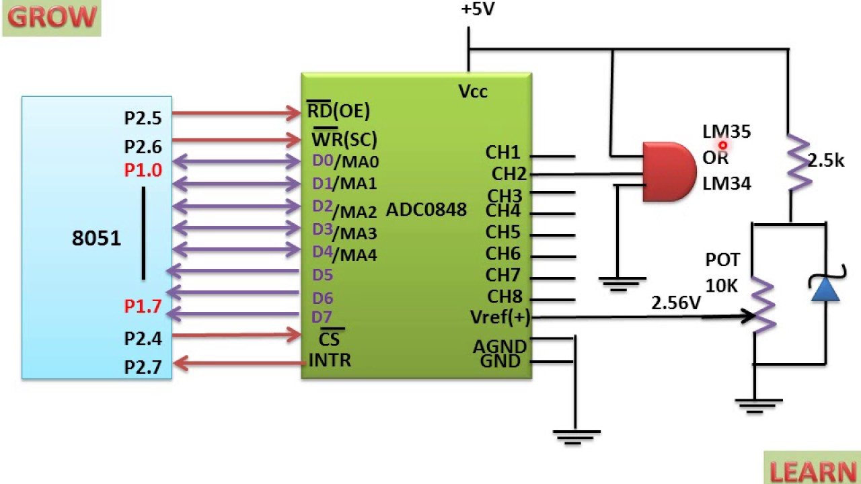

# Q.2 Interface RTC (DS1307) with 8051 Microcontroller.

* RTC stands for real time clock which provides years, months, weeks, days, hours, minutes and seconds based on crystal frequency. RTC consists of inbuilt [RAM memory for data storage](https://www.elprocus.com/stack-memory-allocation-and-register-set-in-8051-microcontroller/). A battery backup will be provided in case of failure of main power supply by connecting a battery to RTC device.

 A few types of RTC devices are:

* Two-Wire Serial Interface (I2C Bus) (I2C: Inter IC Bus)
* Three-Wire Serial Interface (USB BUS) (USB: Universal Serial Bus)
* Four-wire Serial interface (SPI BUS) (SPI: Serial Peripheral Interface)

Here we have considered two-wire interfacing [RTC with 8051 microcontroller such as DS1307](https://www.elprocus.com/rtc-ds1307/).

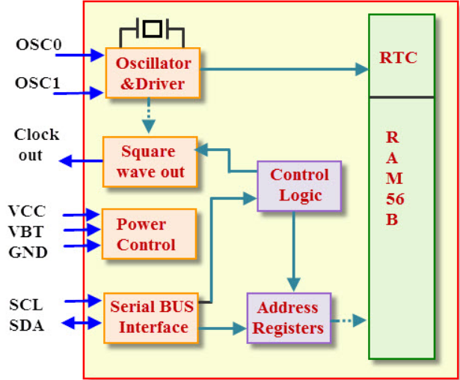

**RTC Internal Block diagram**

**A0, A1, A2:** are address pins of RTC DB1307 chip, which can be used to communicate with the  master device. We can control eight devices with RTC interfacing with[8051 microcontroller](https://www.elprocus.com/know-about-types-of-registers-in-8051-microcontroller/) by A0, A1, A2 bits using I2C protocol.

**VCC and GND:** VCC and GND are power supply and ground pins respectively. This device operated with 1.8V to 5.5V range.

**VBT:** VBT is a battery power supply pin. Battery power source must be held between 2V to 3.5V.

**SCL:** SCL is a serial clock pin and it is used to synchronize data on serial interface.

**SDL:** It is a serial input and output pin. It is used to transmit and receive the data on serial interface.

**Clock Out:** It is an optional square wave output pin.

**OSC0 and OSC1:** These are crystal oscillator pins which are used to provide the clock signals to the RTC device. The standard quartz crystal frequency is 22.768KHzs.

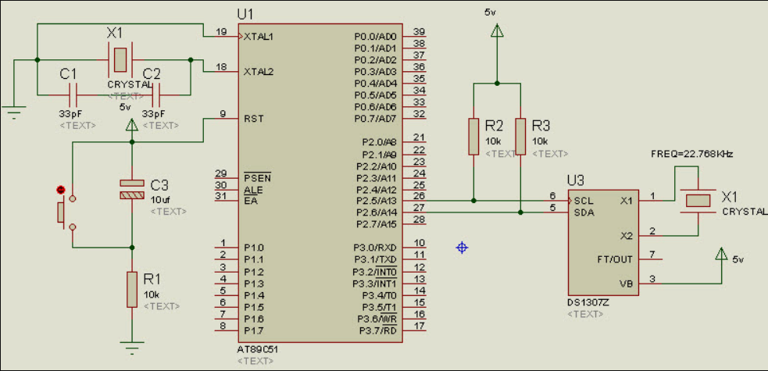

**RTC Interfacing with 8051 Microcontroller**

The figure shows, real time clock interfacing with 8051 microcontroller using I2C bus protocol. I2C is a bi-directional serial protocol, which consist of two wires such as SCL and SDA to transfer data between devices connected to bus. 8051 microcontroller has no inbuilt RTC device therefore we have connected externally through a [serial communication](https://www.elprocus.com/serial-peripheral-interface-spi-communication-protocol/) for ensuring the consisting data.

# Q.3 GSM Based Home Security System using 8051 Microcontroller.

Home security or [home automation](https://www.elprocus.com/home-automation-systems-applications/) can be achieved by adopting central controllers to control home devices or appliances that sense different variables using appropriate sensors. The main aspect of such a system is a [sensory system](https://www.elprocus.com/sensors-types-applications/) that collects the parameter information like temperature, fire, human presence, gas, etc., and sends the corresponding data to the microcontroller or any other processor. This controller is programmed such that when these parameters cross their prescribed limits, it sends the command signals to various final controlling devices like relays, motors and buzzer devices.

This system can be implemented with the use of the following functional blocks:

**Sensory System:** It consists of various sensors like IR sensors for detecting human presence to open or close the doors; LPG gas sensor to detect the gas leakage in kitchens – and, a smoke detector to detect the presence of fire. It is also possible to add [temperature sensor](https://www.elprocus.com/temperature-sensors-applications/), camera and other sensing devices for improving the security of homes. These sensing values are sent to the microcontroller with intermediate circuitry like [Analog to Digital Converter](https://www.elprocus.com/analog-digital-converters/) (ADC).

**Microcontroller:** This is the heart of the system wherein central processing of data takes place. [8051 microcontroller](https://www.elprocus.com/8051-microcontroller-architecture-and-applications/) collects the data or information from various sensors and compares it with appropriate prescribed limits. It is [programmed by embedded C](https://www.elprocus.com/basics-and-structure-of-embedded-c-program-with-examples-for-beginners/) or assembly language in Keil software. By receiving the sensor signals, it takes the corresponding course of action by sending commands to the output devices.

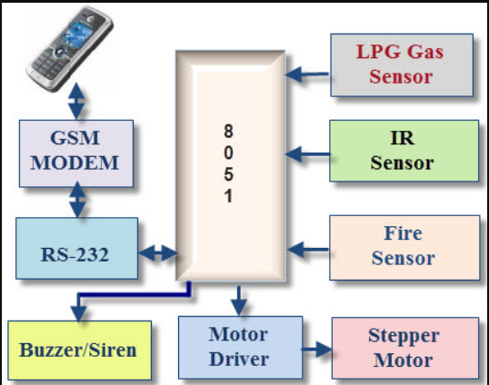

Block Diagram of GSM Based Home Security System

**GSM Modem:** [GSM modem](https://www.elprocus.com/gsm-architecture-features-working/) allows the computer to communicate over the mobile network through calls, SMS and MMS messages. It [consists of a SIM card](https://www.elprocus.com/how-sim-card-works/) and operates over a subscription through a mobile network. It is a highly flexible plug-and-play device capable of connecting to a PC or any microcontroller’s serial port through MAX232IC. This IC is used to convert the TTL logic levels of the microcontroller to a RS232 logic level for enabling serial communication.

**Final Control Devices:** These devices include buzzers and motors with driver ICs and LCDs display. Final control devices generate alarms of different kinds by using buzzers; doors and fire exhauster operations are controlled by using motors. All these devices act upon the commands directed from a microcontroller.

# Q.4 Serial communication using MAX232 in 8051 Microcontroller.

Microcontrollers need to communicate with external devices such as sensors, computers and so on to collect data for further processing. Data communication generally done by means of two methods: Parallel and Serial mode. In the parallel mode data bits are transferred in a fast manner using more number of lines. But when comes to a Microcontroller system, we cannot afford to dedicate many lines for data transfer. So UART or Serial communication in 8051 microcontroller will allow the controller to send and receive data’s just by using two pins.

Serial Communication uses only two data lines to establish communication between Microcontroller and external devices. In this communication data bits are transferred one bit at a time, so the process will be slow. This article describes the Interfacing of 8051 with  PC to establish communication through a serial port RS232.

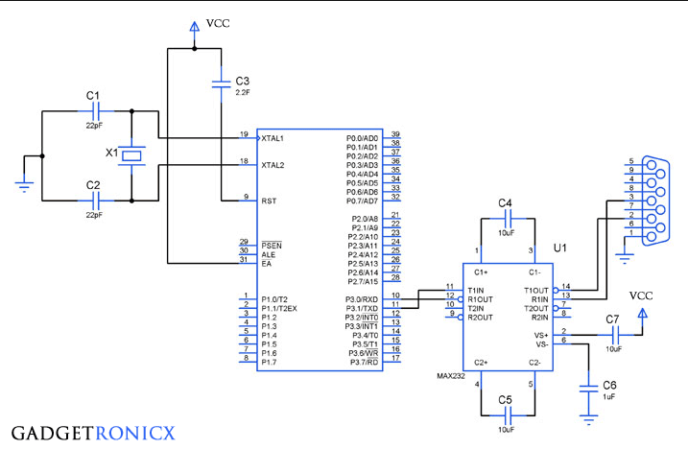

**Serial Communication using 8051**

**RS232 AND MAX232:**

To establish communication between a controller and PC, we must use a serial I/O standard RS-232 which was widely used in PC and several devices. PC works on the RS-232 standards which operates at a logic level of -25V to +25V. But Microcontrollers use TTL logic which works on 0-5V which is not compatible with the RS-232 standards.

MAX232 is a specialized IC which offers intermediate link between the Microcontroller and PC. The transmitters of this IC will convert the TTL input level to the RS-232 Voltage standards. Meanwhile the receivers of this IC will convert RS-232 input to 5V TTL logic levels.

SCON is a bit addressable register is used to set the mode in which the serial communication takes in the controller.

SBUF is a 8 bit register that holds the data needed to be transmitted or the data that is received.